**Day 1**

Session 1

1. Using Scratch

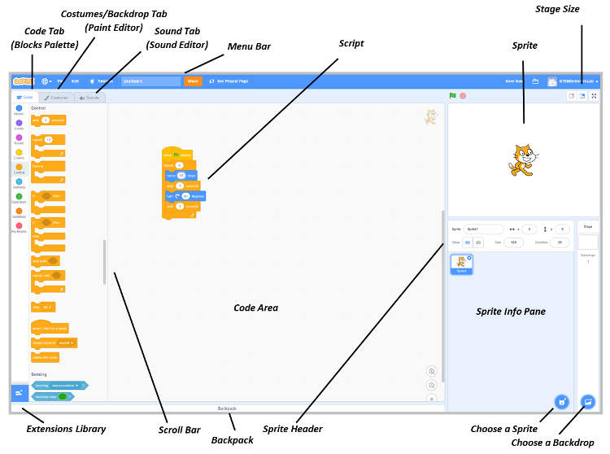

1. Elements of a simple game
   1. Inputs and movement
   2. Loops and repetition
   3. If, Collision, and Touching Colors
   4. Coordinates
2. Demo simple game
   1. Amazing Maze

Session 2

1. Making a simple game (Level 1)
   1. Hungry Cat
   2. Treasure Island
   3. Driving Game
   4. Tunnel of Gold
   5. Cross the Road

Homework

1. Finish making simple game

**Day 2**

Session 1

1. More advanced games (Level 2)
   1. Variables
   2. Picking random numbers
   3. Creating animations
2. Demo
   1. Up in the clouds

Session 2

1. Making more advanced games (Level 2)
   1. Dog and Bone
   2. Catch the Donut

Homework

1. Finish more advanced game

**Day 3**

Session 1

1. Making even more advanced games (Level 3)
   1. Complex Collision Tests
   2. Testing by Location
   3. More Variables
   4. Using variables with sound effects
2. Demo
   1. Flappy Fish

Session 2

1. Making a more advanced game (Level 3)
   1. Helicopter Pilot
   2. Snake
   3. Ping Pong

Homework

1. Finish even more advanced game

**Day 4**

Session 1

1. Make improvements on your favorite Level 1, 2, or 3 Game

Session 2

1. Make improvements on your favorite Level 1, 2, or 3 Game

Homework

1. Finish making improvements on your favorite Level 1, 2, or 3 game

**Day 5**

Session 1

1. Cloning Sprites
2. Making a Level 4 Game
   1. Cat and Mouse
   2. Catch the Pizzas
   3. Rock Blaster
   4. Balloon Blaster
   5. Brick Bouncer

Session 2

1. Finish making a Level 4 Game

Homework

1. Finish Making a Level 4 game

**Day 6**

Session 1

1. Functions
2. Making a Level 5 Game
   1. Penguin Jumper
   2. Tower Smash

Session 2

1. Finish making a Level 5 Game

Homework

1. Finish Making a Level 5 game

**Day 7**

Session 1

1. Making improvements to a Level 5 Game

Session 2

1. Finish making improvements to a Level 5 Game

Homework

1. Finish making improvements to a Level 5 game

**Day 8**

Session 1

1. Planning your own game (groups of 2)

Session 2

1. Refining your plans for your own game
2. Peer review

Homework

1. Finalize plans for your own game

**Day 9**

Session 1

1. Build your own game

Session 2

1. Continue building your own game

Homework

1. Finish your own game

**Day 10**

Session 1

1. Test and debug your game

Session 2

1. Demo your game